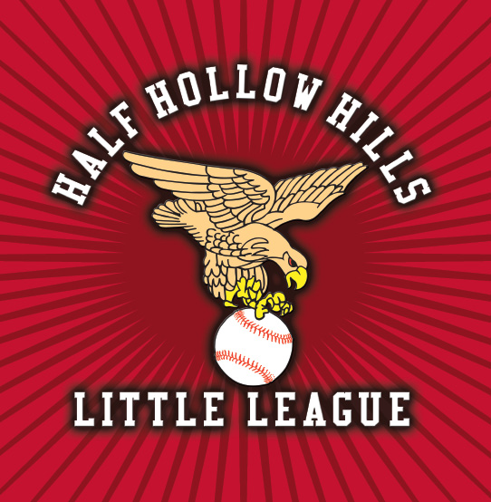
Intermediate (50/70) Tournament Booklet
New York State Little League Championships
Hosted by Half Hollow Hills Little League – District 34
Otsego Park – Dix Hills

CONGRATULATIONS ON YOUR SECTION CHAMPIONSHIP!
MUST CONTACT STATE HOST IMMEDIATELY
Please contact Steven Muraco immediately with:
• Section Number
• League Name & District
• League President Contact Info
• Manager & Coaches Info
• Full Roster (Excel Format)
Email: muraco@mvsmailers.com
Cell: 631-445-6531

Welcome
On behalf of Half Hollow Hills Little League and District 34, we welcome you to the New York State Championships. We are proud to host this tournament at Otsego Park and provide a first-class experience for all teams.

Tournament Contacts
Steven Muraco – Tournament Director
631-445-6531
muraco@mvsmailers.com

TO: All District Administrators and Section Coordinators
SUBJECT: 2026 Intermediate 50/70 League New York State Championship
DATES: July 13, 2026 – July 18, 2026
HOST: District #34
HOST LEAGUE: Half Hollow Hills Little League
HOST FIELD: Otsego Park, 55 Otsego Avenue, Dix Hills, NY 11746
Contact Information:
District 34 Administrator / Half Hollow Hills Little League President: Steve Muraco
Phone: 631.445.6531
Email: muraco@mvsmailers.com
Section Winner Notification:
Upon completion of sectional play, the manager of the winning team is required to promptly contact the state tournament director, Steven Muraco, via email. Please provide comprehensive details regarding the team that will represent your section at the state championship.
Schedule of Events:
- July 12, 2026, 7:30 PM: Managers Meeting and Team Affidavit Verification (All Teams)
Location: Otsego Park, 55 Otsego Avenue, Dix Hills, NY 11746
Important Note:
The tournament draw will take place during the managers’ meeting.
Please ensure all team information is submitted, along with a photograph of the championship team displaying the 2026 Sectional Flag.

Manager’s Meeting
Location: Otsego Park
Date: 7/12/26
Time: 7:30 PM
AGENDA:
- Complimentary buffet provided for managers, coaches, and officials
- Discussion of rules and competition schedule
- Affidavit review for double elimination format
- Q & A
- Tournament Draw
- Practice Schedule
GAME SCHEDULE
- Initial game times to be determined.
- The practice field will be available throughout the day; a detailed practice schedule will be provided at the Managers’ Meeting. Practice sessions are scheduled in 1.5-hour increments from 9:00 AM to 3:00 PM.
- Batting cages are accessible from 9:00 AM to 8:00 PM in 1.5-hour intervals.
Tournament:
- The tournament will follow a double elimination format.
Housing:
- Meals and lodging arrangements are the responsibility of each participating league.
Concessions:
- A fully stocked refreshment stand will be open before, during, and after each game. Convenient restroom facilities are also available on site.

2026 Int. 50/70 Game Schedule

7/13 – Game Times - 10 AM – 3 PM
7/14 – Game Times - 10 AM – 3 PM
7/15 – Game Times - 10 AM – 3 PM
7/16 – Game Times - 10 AM – 3 PM
7/17 – Game Times – 10 AM – Noon – Championship & If Necessary, Games
7/18 Rain Date

TOURNAMENT OFFICIALS
District 34 Administrator/President HHHLL/ Tournament •Director:
Steven Muraco, 631.445.6531(cell)
Muraco@mvsmailers.com

OTHER CONTACT1INFORMATION
MAILING ADDRESS:
Half Hollow Hills LL
27 Jagger Court
Melville, NY 11747
Muraco@mvsmailers.com

LEAGUE WEBSITE: www.hhhllhawks.com

Tournament Website: www.district34ll.com

TOURNAMENT RULES AND GUIDELINES

UNIFORMS AND EQUIPMENT:
The team manager and their staff are fully responsible for uniforms and equipment.
Every player must wear a numbered uniform featuring the Little League Patch on the upper left side of their shirt, or wherever it best fits. All playing equipment used by participating teams must meet Little League's specifications, such as NOCSAE-approved helmets and Little League-approved bats.
It's recommended that each team brings at least two sets of catchers' gear.
Managers and coaches are not allowed to wear tank-top style shirts or cut-off jeans during games.

CODE OF CONDUCT:
Managers, coaches, and spectators must always set a positive example. Profanity or unsportsmanlike conduct from any manager, coach, player, or spectator will not be tolerated.

Managers & Coaches
All teams must follow Little League rules.
Uniforms must include official patch.
Unsportsmanlike conduct will not be tolerated.

Field Location
Otsego Park, 55 Otsego Ave, Dix Hills NY
14 fields, batting cages, concessions, parking.
Location: Dix Hills, NY 11746 (All Fields at one Complex)
Fields: 14 beautifully manicured fields, covered dugouts, practice fields
Batting Cage: Located at Above Complex (Reservations assigned At Managers Meeting)
Parking: Open Parking lot located at Otsego Avenue & Commack Road Entrances to Park
Bathrooms: Located near Snack Stand & Field # 9
Seating: Bleacher seating is available at all fields & space to set up chairs under trees available in the outfield, please plan accordingly
Concession Stand: Fully stocked concession stand at both fields.

Map
https://maps.apple.com/place?place-id=I6FCA3F470A842CD5&address=Commack+Rd%2C+Dix+Hills%2C+NY+11746%2C+United+States&coordinate=40.788080%2C-73.312948&name=Otsego+Park&_provider=9902

Hotels
Hampton Inn Commack
Hyatt Regency Long Island
Holiday Inn Express
Radisson Hauppauge

Restaurants & Attractions
Adventureland
Robert Moses Beach
Captree State Park
Tanger Outlets

Medical Facilities
Northwell Health Urgent Care nearby.
AED available at fields.

