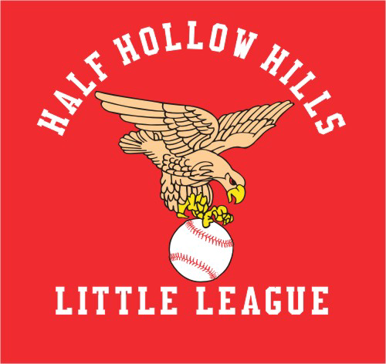

Saturday April 4, 2020
Manager/Coach Meeting

West Hollow Middle School
250 Old East Neck Road
Melville, NY 11747

Coach’s Mandatory Meeting location will be West Hollow Middle School, See below agenda or go to www.hhhllhawks.com for below details:

ALL VOLUNTEERS MUST COMPLETE THEIR VOLUNTEER INFO ON THE ABOVE REGISTRATION WEBSITE ASAP (If it was not done during the registration process), IF NOT YOU CANNOT COACH. To complete your volunteer info sign In Using Your Email & Password Set-Up during Registration Process using Coach’s link.

THIS IS A MANDATORY MANAGERS/COACHES MEETING.

4/4/20 AGENDA:

10 AM – 11:30 AM - Positive Coaches Alliance Workshop

11:45 AM – 1 PM - First Aid

1:15PM - 2PM – League Presentation

All Volunteers MUST be Certified in ALL Above Classes.

The Big Al Clinic & Safety Clinic MUST Be taken online & you must pass a test & get certified. All Volunteers MUST pass these classes. (Info to follow)

The PCA Clinic MUST Be Attended in Person on 4/4/20. Certification/Re-Certification can either be done in person or on-line.

The League Presentation MUST be attended in person by all Volunteers.

If You Certify/Re-certify The PCA Clinic on Line You Will Have to Pay The $30 Fee Yourself, If You Attend On 4/4/20 HHHLL Will Pay All Costs.

First Aid Clinic must be attended in person on 4/4/20 or supply proof of attending another first aid course on an alternative date.

In Order to Obtain a Volunteer Shirt and Hat You MUST be Certified in all classes.

